When it works, I can see this in the server details:

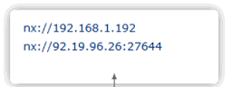

But then sometimes as you can see it is still on the same local IP but this time the system doesn’t display the external IP:

